Testing of the GenAI for FSxN

Build 5ed60def-73a9-4cf0-a743-f9f69156336b
Test Runtime Date: 8th of May 2026 Friday
Deployment Time: 53Mins

- Workshop Objective needs some alignment, cosmetic changes, and some language fine tuning. The workshop objective is to help participants build persistent storage layers for the GenAI chatbot at scale with EKS auto mode scaling and improve operational efficiency. I can help to fine tune when you are ready.......

Additional Reading: put a summary in top and hide the text. If anyone wants to read it let them click more and read it.

This workshop demonstrates how to deploy a Generative AI inference platform on AWS by serving the open-source Mistral-7B-Instruct Large Language Model through the vLLM framework on Amazon EKS, using AWS Inferentia2 accelerators for cost-efficient high-performance compute and Amazon FSx for NetApp ONTAP (with NetApp Astra Trident CSI driver) for persistent shared storage that only requires a one-time model download. Participants benefit from a production-ready architecture that combines EKS's automatic scaling and orchestration, vLLM's state-of-the-art serving throughput with PagedAttention and continuous batching, Inferentia2's lowest-cost inference in EC2, and FSx for ONTAP's enterprise storage features like snapshots and data tiering — all accessible through a simple Open WebUI chat interface, giving teams a complete, scalable, and cost-optimized GenAI solution without managing infrastructure complexity. Further reading click here

Connect to your AWS lab environment
This section is very similar to our previous labs. The only challenge is again with the browser past issue.
Deploy Trident CSI Driver for Amazon FSx for NetApp ONTAP

This section was very smooth and easy to deploy the trident csi driver

You can also verify the backend details with put an image and highlight what they need to look at it.

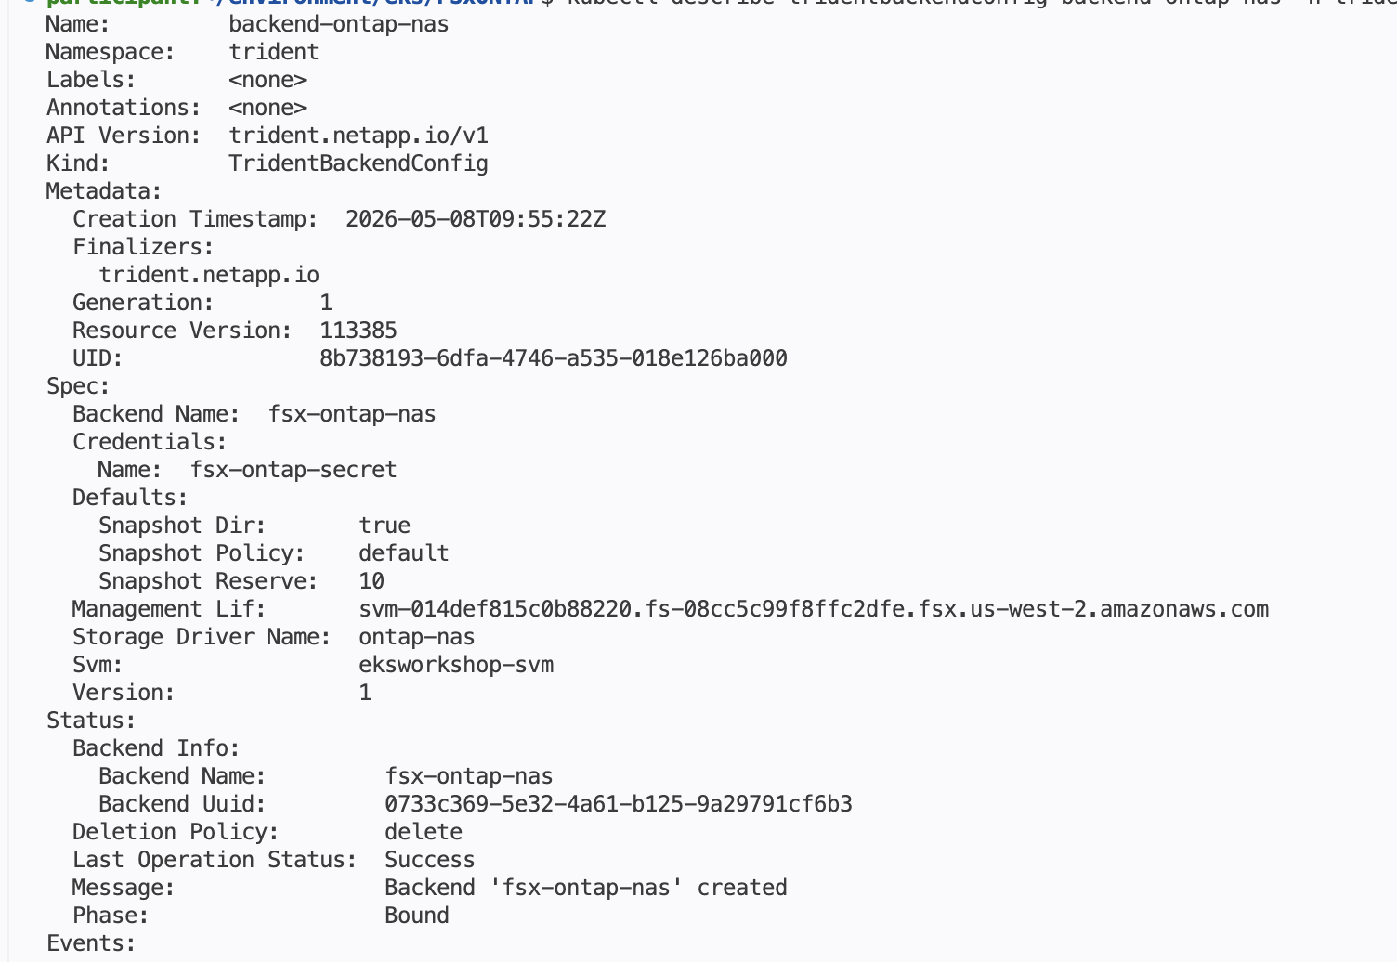

Step 2: Create the StorageClass
In this step we show the CAT output but not instructing to run it and observe

Step 3: Create the PersistentVolumeClaim
Again same thing in step 3 lets put a step
cat ontap-pvc.yaml

This module also completed successfully.

View FSx for ONTAP details in the Amazon FSx console
My suggestion is lets move the viewing of ONTAP details before deploying the trident operator and in this section post dynamic provisioning just go and view again the difference in new volume created dynamically. This way the participant can relate...

Deploy vLLM on AWS Inferentia nodes for model Inference
Update the latest screenshot
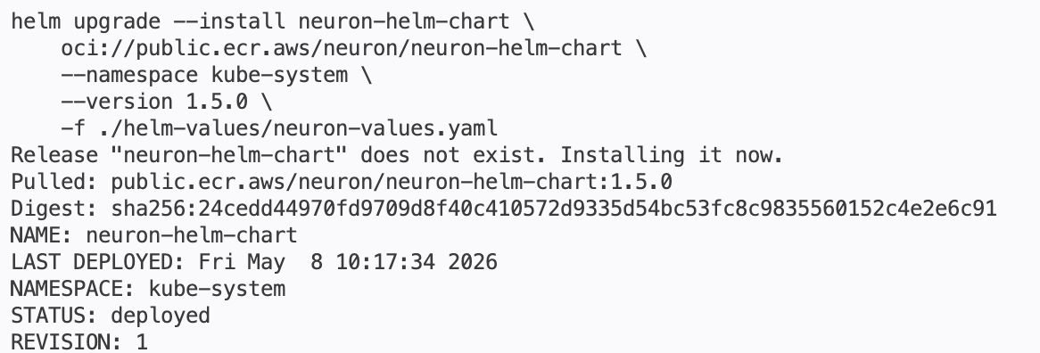

Step 2: Create EKS Auto Mode NodePool and EC2 NodeClass for AWS Inferentia Accelerators
Lets take a look at the EKS Auto NodePool definition for the inferentia NodePool before we apply it. This configuration will create a new nodepool for AWS Inferentia (using "INF2" type for instance-family), where the AWS INF2 compute nodes will power Generative AI application (vLLM pod).

When cat inferentia_nodepool.yaml
What is expected from the participants to look at it?
In the step 4:
Screenshot can be improved.

The above module is good to go

Deploy Open WebUI chat application to interact with model
Deployment of the WebUI was ok and the running of task was also good similar to our previous workshops. The context window was not failing this time. All goood

Setting up observability stack

This module was smooth

Deploy vLLM & Neuron monitoring dashboards

Dash board module is also good to go...

FSx for ONTAP Volume Snapshots

Step 2: View automatic snapshots from within a pod
The snapshot module need to be re-looked I was not able to find the snapshot.
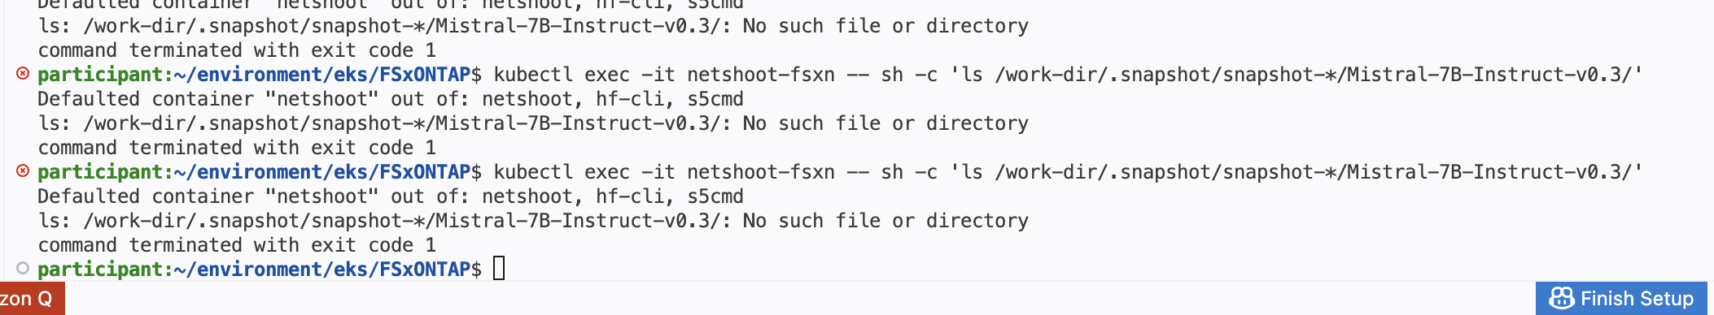

My overall observation is that the flow is good, it goes through the same steps as we expected from our previous workshops using the vLLM with Mistral 7B model which takes only text prompts. Bringing FSxN with MAZ will provide how we build storage layer resiliency with Zero RPO and show case live failover and spin another pod loading the model and no impact on the compute as the storage is always accessible. This is what we did in the first workshop that we delivered in 2022. MAZ + snapshot and storage efficiency + performance makes FSxN unique compared to other FS in FSx family.

